ASTA607: COMPUTATIONAL STATISTICS I
Q.1
a) describing the dataset
?crabs

Description
The crabs data frame has 200 rows and 8 columns, describing 5 morphological measurements on 50 crabs each of two colour forms and both sexes, of the species Leptograpsus variegatus collected at Fremantle, W. Australia

b) loading the dataset and displaying its structure
data("crabs")

str(crabs)
'data.frame': 200 obs. of 8 variables:
$ sp : Factor w/ 2 levels "B","O": 1 1 1 1 1 1 1 1 1 1 ...
$ sex : Factor w/ 2 levels "F","M": 2 2 2 2 2 2 2 2 2 2 ...
$ index: int 1 2 3 4 5 6 7 8 9 10 ...
$ FL : num 8.1 8.8 9.2 9.6 9.8 10.8 11.1 11.6 11.8 11.8 ...
$ RW : num 6.7 7.7 7.8 7.9 8 9 9.9 9.1 9.6 10.5 ...
$ CL : num 16.1 18.1 19 20.1 20.3 23 23.8 24.5 24.2 25.2 ...
$ CW : num 19 20.8 22.4 23.1 23 26.5 27.1 28.4 27.8 29.3 ...
$ BD : num 7 7.4 7.7 8.2 8.2 9.8 9.8 10.4 9.7 10.3 ...

c) Frequency table for species and sex

Frequency_SS <- table(crabs$sp,crabs$sex)
> Frequency_SS

F M
B 50 50
O 50 50

d) constructing bar chart
par(mar=c(4,4,1,1))
> barplot(Frequency_SS,xlab = "crabs",ylab = 'Frequency', col=2:4 , main = "Morphological Measurements on Leptograpsus Crabs")

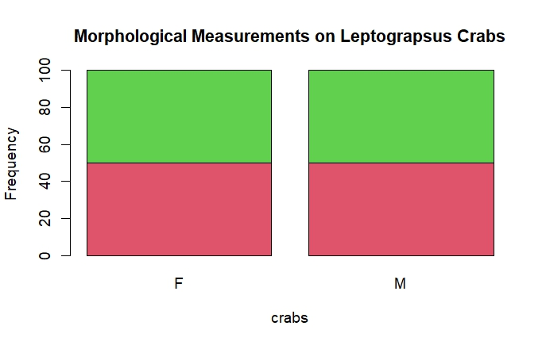
Figure 1:bar chart summarizing the group composition.
From the above figure , the morphological measurements on the leptograpus crabs. The diagram show the balance across the groups. Each of two colour forms and both sexes, of the species.

Q2 a) producing a box plot
boxplot(crabs$BD~crabs$sp, xlab = 'species',ylab = "BD" , main= "Distribution of body depth by species", col= rainbow(3), )

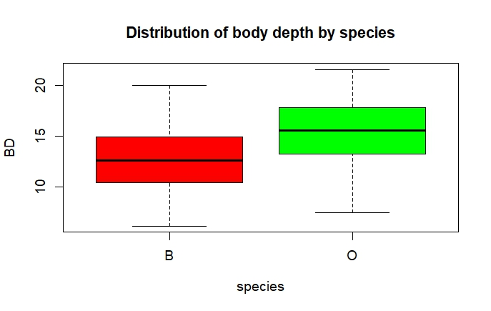
Figure 2: boxplots showing the distribution of body depth.
The B species is equally distributed. The O species has a outlier .
b) central tendency between the species and sex
CT <- crabs%>% group_by(sp)%>%summarise(mean=mean(BD),median=median(BD))
> CT
# A tibble: 2 × 3
sp mean median
<fct> <dbl> <dbl>
1 B 12.6 12.6
2 O 15.5 15.6

CTsex <- crabs%>% group_by(sex)%>%summarise(mean=mean(BD),median=median(BD))
> CTsex
# A tibble: 2 × 3
sex mean median
<fct> <dbl> <dbl>
1 F 13.7 13.8
2 M 14.3 14.2

Q 3
- Producing a histogram
par(mfrow=c(1,2))
> hist(subset(crabs,sp=="B")$CL, xlab="B", ylab="Frequency", col=2, main="Carapace length distribution by Species")
> hist(subset(crabs,sp=="O")$CL, xlab="O", ylab="Frequency", col=3, main = "Carapace length distribution by Species")

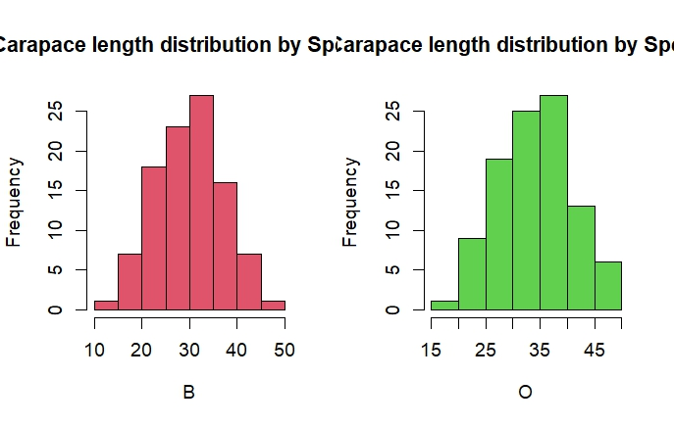
Figure 3: histogram of carapace length for each species.
From the above diagram, comparing the carapace length distribution by species shows that the species B is symmetrically distributed there are no outliers as compared to the negatively skewed O species.
Q4. a) computing the various means
MM_FL <- mean(crabs$FL)
MM_RW <- mean(crabs$RW)
MM_CL <- mean(crabs$CL)
MM_CW <- mean(crabs$CW)
MM_BD <- mean(crabs$BD)

Prints:
[1] 15.583
> MM_RW
[1] 12.7385
> MM_CL
[1] 32.1055
> MM_CW
[1] 36.4145
> MM_BD
[1] 14.0305

- Constructing a grouped bar chart
par(mfrow= c(1,5))
par(mfrow=c(1,5) )
barplot(MM_FL, xlab = 'FL', ylab = 'means', col = 2)
barplot(MM_RW, xlab = 'RW', ylab = 'means', col = 3)
barplot(MM_CL, xlab = 'CL', ylab = 'means', col = 4)
barplot(MM_CW, xlab = 'CW', ylab = 'means', col = 5)
barplot(MM_BD, xlab = 'BD', ylab = 'means', col = 6)

c)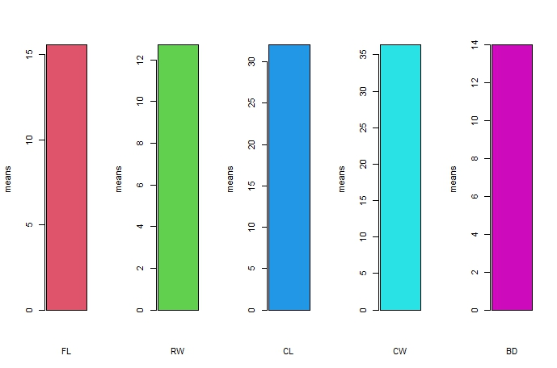
Figure 4:group bar chart comparing of means.
Q.5
cleanNA<- na.omit(crabs)

## visualizing
pairs(cleanNA, main = "Scatterplot Matrix of the five measurements of the crabs dataset ", col= rainbow(7))

Figure 5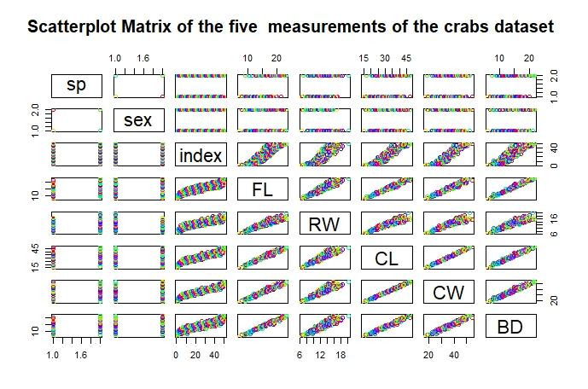
Figure 6: scatterplot of the crabs’ data set
There is a strong positive correlation of the relationship among variables. It seems to be a linear relationship.

